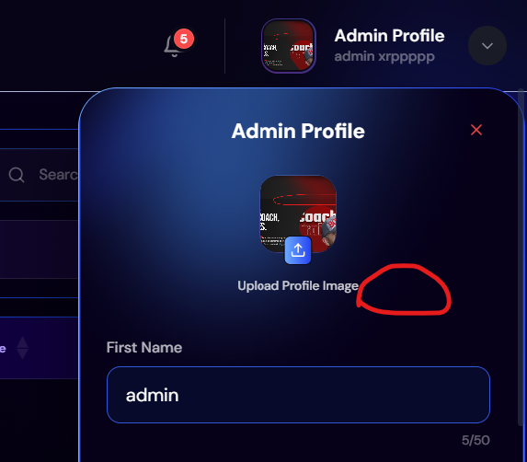
Optional keyword missing acc to figma
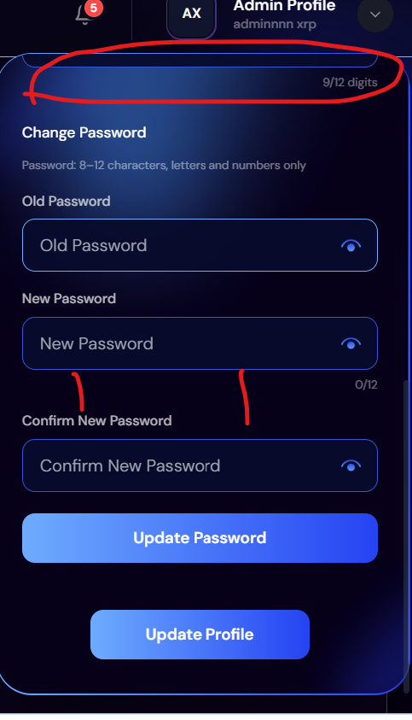
Fields gap issue
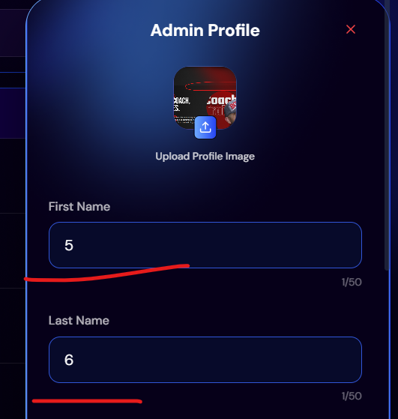
Name Easily set to 5, 6
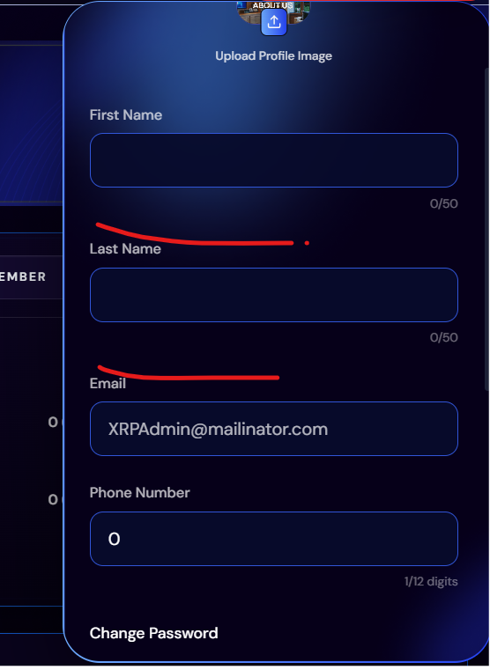
When admin blanks all the fields, then visit any page like listing after that again open the profile. The fields remain blank

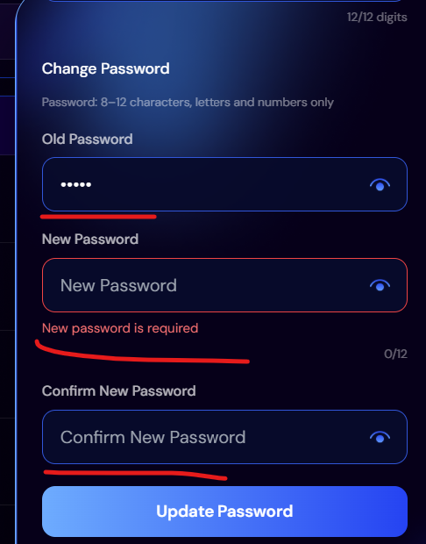
Error message is shown 1 by 1. Old password in incorrect and both password and new password fields are empty but is shows error only on new password field
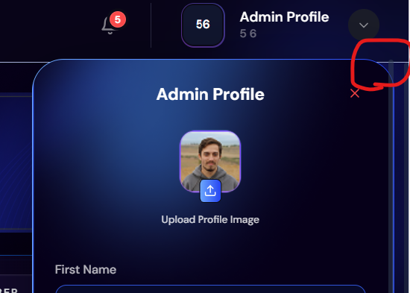
Scroll bar overflow and should be more highlighted

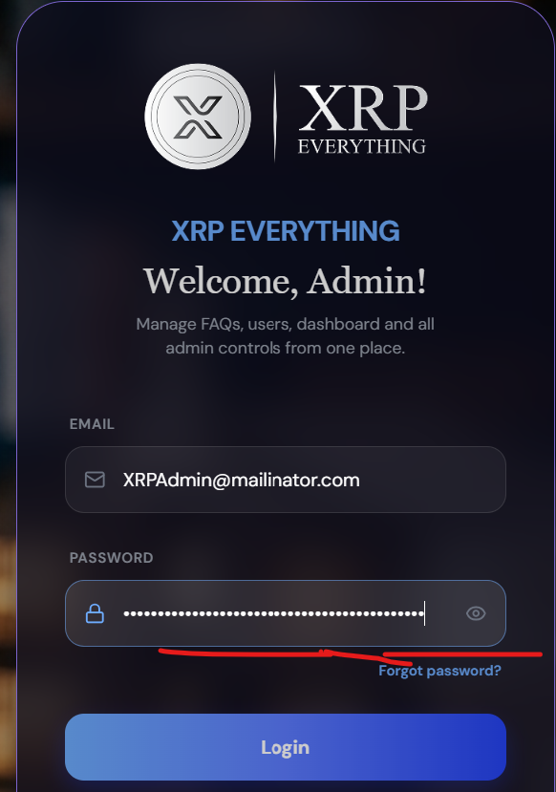
Limit should be 12 char when new password limit is max 12 char
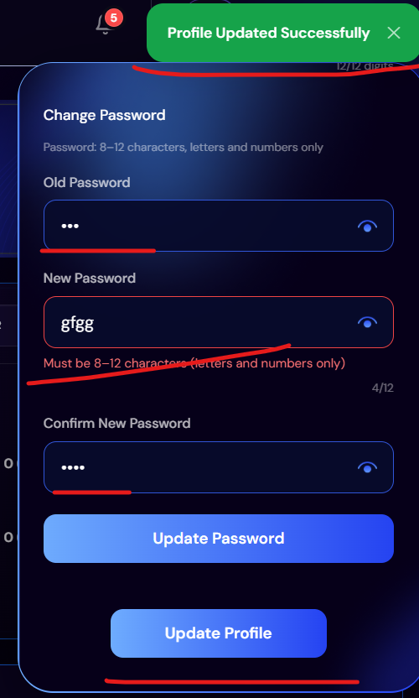
How profile is updating when having password errors

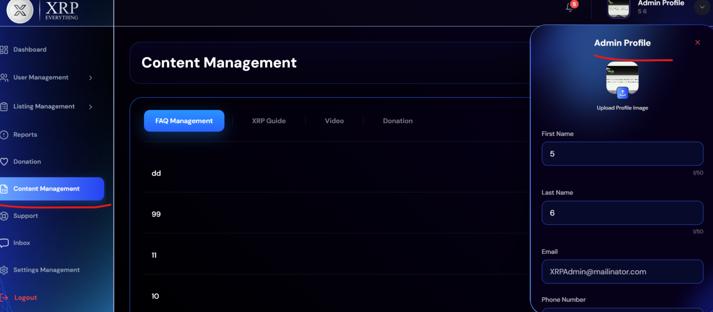
When click on any other section, the profile page should be close
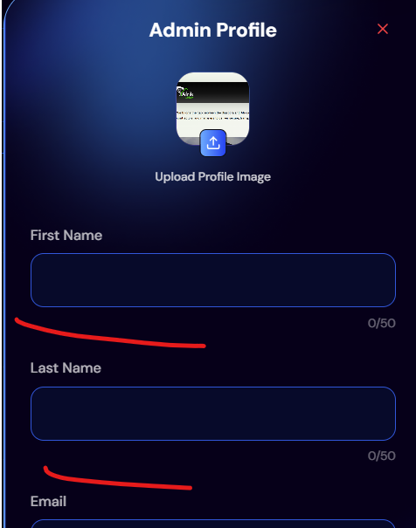
error message should be display below the fields

